1. **A Deep Learning Approach to Ancient Egyptian Hieroglyphs Classification (2021) Reimplement Manually**

Dataset: Morris Franken and their own dataset, they are images and their Gardiner codes

Models used: 3 standard models and a new proposed model by them Glyphnet

Scope: CV classification GCode

They didn’t include any qualitative results (what the classification looked like).

They only provided the code for resnet-50 not the dataset they used nor the rest of the code.

Links:

<https://ieeexplore.ieee.org/stamp/stamp.jsp?tp=&arnumber=9528382#page=5.22>

<https://github.com/dqj5182/Egyptian_Hieroglyph_Classification_ConvNet/tree/main>

1. **Egyptian Hieroglyphs Segmentation with Convolutional Neural Networks (2023) Not useful**

Datasets: Morris Franken and added scraped images

Models: Mask R-CNN

Scope: CV segmentation

Results:

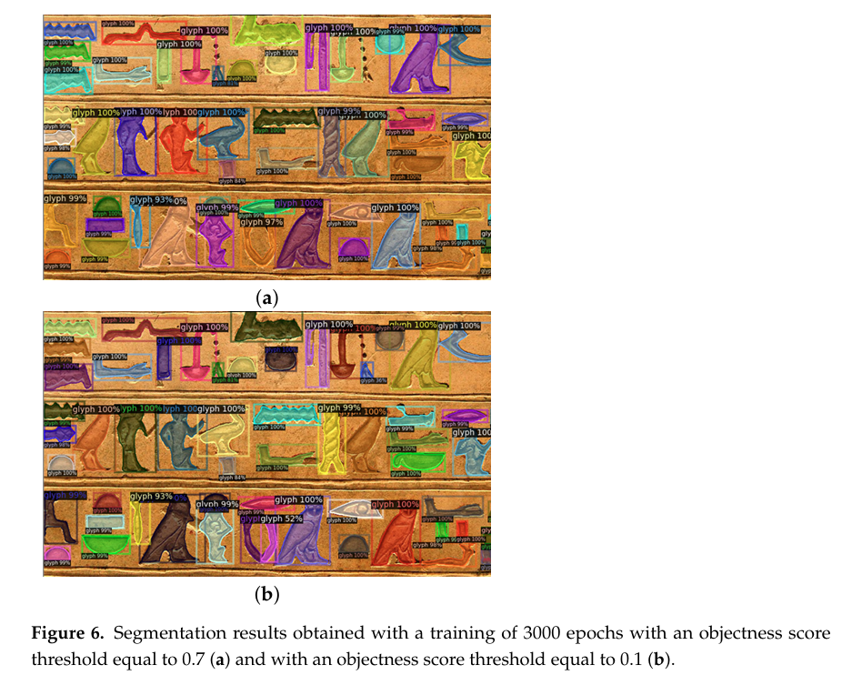

No code or dataset available.

Link: [Egyptian Hieroglyphs Segmentation with Convolutional Neural Networks](https://www.mdpi.com/1999-4893/16/2/79)

1. **An AI Based Automatic Translator For Ancient Hieroglyphic Language From Scanned Images To English Text Invalid sar2no asln men paper tanya**
2. **Image Based Hieroglyphic Character Recognition very basic ziad hydrabna belrosas**

Dataset: not clarified

Models: digital image processing algorithms and mapping

Scope: CV and NLP bas very very basic w malhosh ma3nah

Results:

No code or dataset available

Link:

[(PDF) Image Based Hieroglyphic Character Recognition](https://www.researchgate.net/publication/332947534_Image_Based_Hieroglyphic_Character_Recognition)

1. **Automatic Egyptian Hieroglyph Recognition by Retrieving Images as Texts Morris Franken Dataset**

[**JSesh | JSesh**](https://jsesh.qenherkhopeshef.org/) **tool used for constructing the datase**

[**GitHub - morrisfranken/glyphreader: A deeplearning approach to classifying the ancient Egyptian hieroglyphs**](https://github.com/morrisfranken/glyphreader/tree/master)

Model and dataset available

[Egyptian Hieroglyphs: GlyphDataset](https://www.kaggle.com/datasets/ahmedsamir1598/glyphdataset/data) Kaggle

1. **Deciphering the Ancient Script: A Novel Approach to Hieroglyphic Language Translation**

No proof le ay haga